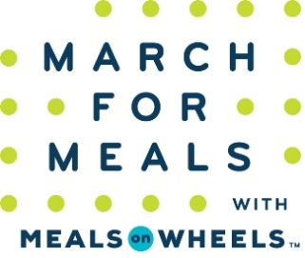
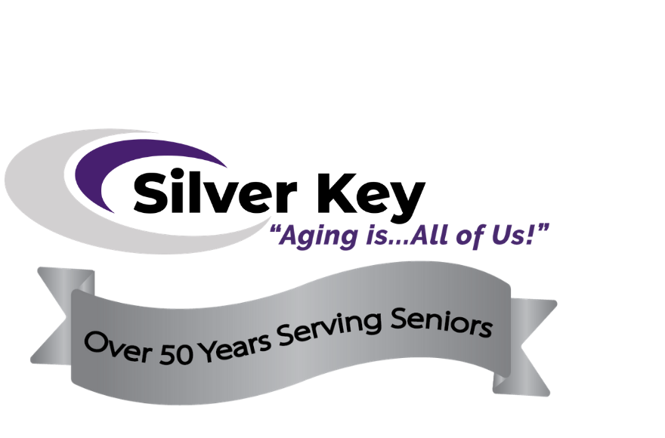

Derek Wilson
Chief Strategy Officer
Silver Key Senior Services
719-884-2313
dwilson@silverkey.org
FOR IMMEDIATE RELEASE

Silver Key Senior Services JOINS IN MONTH-LONG March for Meals CELEBRATION WITH COMMUNITIES NATIONWIDE

Support will help to fight senior hunger and isolation in the Pikes Peak region AMID THE PANDEMIC AND BEYOND

Colorado Springs, CO, March 2, 2021 – Silver Key announced today that it will be participating in the 19th annual March for Meals – a month-long, nationwide celebration of Meal on Wheels and our senior neighbors who rely on this essential service to remain healthy and independent at home, now even more so amid the COVID-19 pandemic. Silver Key’s celebration will include various activities throughout the month of March, including Silver Key’s celebration honoring those in the community that make Meals on Wheels a possibility throughout the month of March. Silver Key will also have select community dignitaries and local celebrities onsite volunteering during Community Champions Week, March 22-26 to help gain awareness and visibility for this important cause.

“In the last year, we have experienced a 65% increase in the demand for our services in the Pikes Peak region,” said Derek Wilson, Chief Strategy Officer for Silver Key Senior Services. “We have been in awe of the outpouring of support, and there’s still much we can do to ensure everyone in need of our vital lifeline can benefit from being well-nourished and more connected to our community through this challenging time and beyond.”

Silver Key delivered over 48,000 meals throughout 2020 and the COVID-19 pandemic and was able to persevere in services, despite restrictions and barriers to reach our already isolated seniors.

The annual March for Meals celebration commemorates the historic day in March of 1972 when President Nixon signed into law a measure that amended the Older Americans Act of 1965 to include a national nutrition program for seniors 60 years and older. Since 2002, community-based Meals on Wheels programs from across the country have joined forces for the annual awareness campaign to celebrate this successful public-private partnership and garner the support needed to fill the gap between the seniors served and those still in need.

“The pandemic has introduced many of us to the newfound and harsh realities of food insecurity and social isolation – something that far too many seniors experience as their daily norm. More than ever, we must rally around our essential community-based programs that serve as lifelines to a growing number of people in need, to enable their own long-term vitality,” said Ellie Hollander, President and CEO of Meals on Wheels America. “Even when we make it through this unprecedented time in our nation's history, there will still be millions of vulnerable older adults who will rely on that familiar knock on the door that provides peace of mind and hope beyond the meal itself. Please join us in celebrating the power and importance of Meals on Wheels this March and always.”

For more information on how you can volunteer, contribute or speak out for the seniors in the Pikes Peak region this March, visit www.silverkey.org.

About:
For decades, Silver Key has been delivering hot, nutritious Meals on Wheels to low-income seniors who are coping with hunger and isolation. Caring V.I.P. volunteers bring meals to homebound older adults along with a friendly check-in of reassurance. Hot meals are available three days a week. Clients must be 60 years or older and homebound. Please contact Silver Key on our Silver Line 719-884-2300 or email at info@silverkey.org to arrange for a new client assessment by phone or in-person.

