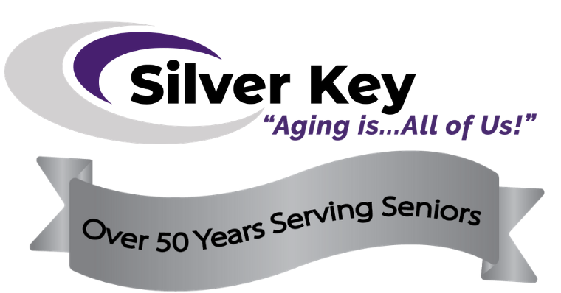

Silver Key’s Engaged at Every Age
50th Anniversary Gala
Auction Donation Form

About the Event
Silver Key is celebrating a milestone anniversary this year—50 years of caring service to our local senior community! This ticketed event will feature live entertainment, silent auction and raffle, casino-style games, dancing and more. The event is August 7, 2021 at Boot Barn Hall and the expected attendance is 550, pending COVID regulations, plus a large virtual attendance as well.

Benefits of Donating
- Recognition in the event program, at the auction tables, and on the digital auction platform.
- Tax deductible to the extent allowed by law

About your Company
Company Name:
Contact person: |  | Title:
Address:
City, State, Zip:
Phone: | Email:

About your Donation
Yes, we want to make a donation of:
Fair Market Value: $: | Expiration Date:
How will the item(s) be delivered? (indicate below)
- Item Enclosed
- Item needs to be picked up
- Item will be delivered
- I will include a certificate describing the item contents and value
- Please make a certificate for the item based on the description and restrictions below:
Description of item(s):

Restrictions on item or its use:

Silver Key Contact Information
Jessica Arana is the Silver Key contact for completed donation forms, delivery of auction item, certificate, etc., and for any questions.

Jessica Arana, Events & Donor Relations Manager
1625 S. Murray Blvd., Colorado Springs, CO 80916
Direct: (719) 884-2325, Email: jarana@silverkey.org

Thank you!
Your support will allow us to continue to support the amazing seniors we currently serve and also to extend our reach to the hundreds of older adults we have yet to meet. Thank you for considering our request and helping us with the auction. Together, we are making the Pikes Peak region the best community in the nation to age!

