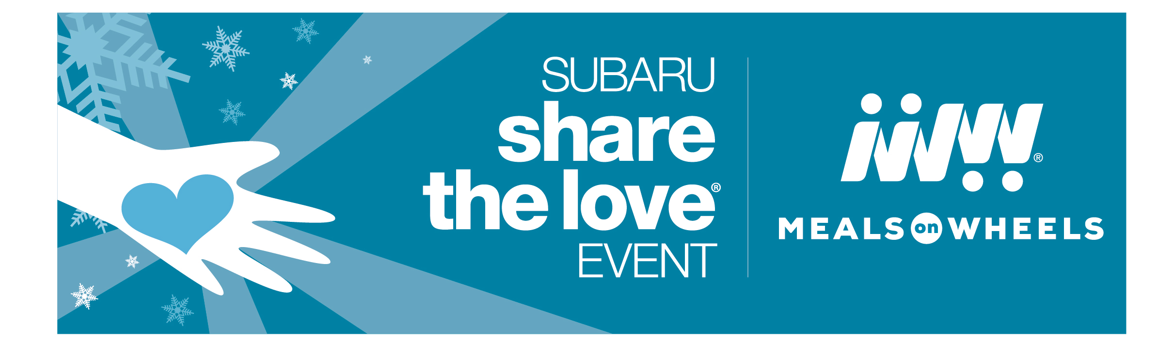

Share the Love with Vulnerable Seniors This Year

Exciting news! For the 14th year running, the Meals on Wheels network is participating in the 2021 Subaru Share the Love Event. Over the past thirteen years, Subaru and its retailers have helped Meals on Wheels to deliver more than 2.5 million meals nationwide to seniors in need.

Why does Subaru support Meals on Wheels? Too many seniors are struggling to stay independent and healthy. One in four seniors lives alone in isolation and one in seven seniors might not know from where their next meal is coming. This is simply unacceptable, which is why Silver Key provides the nutritious meals, friendly visits and safety checks to the seniors of the Pikes Peak region. This vital support keeps seniors in their own homes, where they want to be.

We’re incredibly grateful to Subaru and its Retailers for supporting our organization and the seniors we serve. With that in mind, we thought you might want to learn a little bit more about the Subaru Share the Love Event.

HERE’S HOW IT WORKS

This November 18, 2021, through January 3, 2022, for every new Subaru vehicle purchased or leased, Subaru will donate $250 to the customer’s choice of participating charities.* Meals on Wheels is one of four national participating charities and has been since the inception of the event. Through this event, as a member of Meals on Wheels America, Silver Key will receive a share of the donation from Subaru vehicles sold at participating Subaru Retailers.

And remember: this holiday season you can ensure our senior neighbors are not forgotten, when you purchase or lease a new Subaru and select Meals on Wheels as your charity of choice.

*Disclaimer: Subaru will donate $250 for every new Subaru vehicle sold or leased from November 18, 2021, through January 3, 2022, to four national charities designated by the purchaser or lessee. Pre-approved Hometown Charities may be selected for donation depending on retailer participation. For every new Subaru vehicle sold or leased during the campaign period, participating retailers will donate a minimum of $50 in total to their registered Hometown Charities. Purchasers/lessees must make their charity designations by January 14, 2022. The four national charities will receive a guaranteed minimum donation of $250,000 each. See your local Subaru retailer for details or visit subaru.com/share. All donations made by Subaru of America, Inc.

